
Parents Meeting: Set 1 Sounds

What can you do to help at home?

1. Use pure sounds, not letter names
2. Teach the picture names
3. Practise reading sounds speedily - ‘review, review, review’
4. Use the handwriting phrases for writing only.

There are free video tutorials on our website – www.ruthmiskin.com

Select ‘More and International’ at the top, then ‘Home reading’ from the drop-down list:

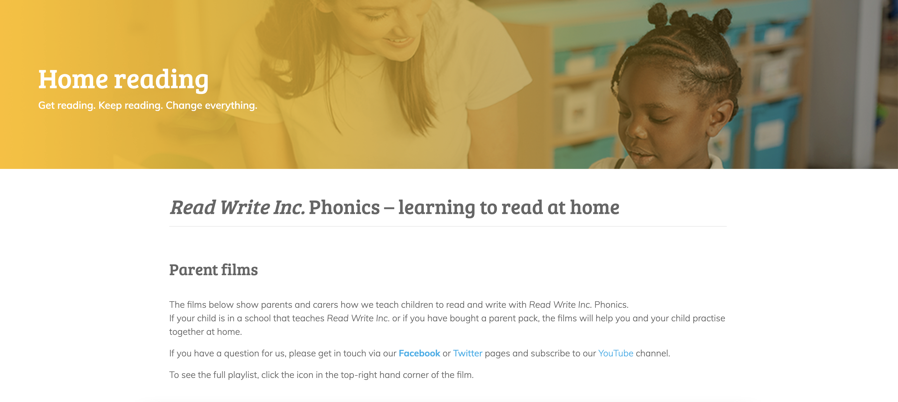

We’re also on Facebook – www.facebook.com/miskin.education

Free e-books for home reading:
http://www.oxfordowl.co.uk/Reading/

